
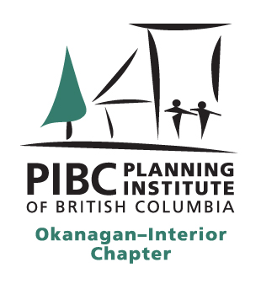


The Planning Institute of BC
In partnership with the City of Penticton host:

Current Topics in Planning Law
with Jordan Adam and Guy Patterson (Young Anderson Barristers & Solicitors)

Thursday, September 17, 2026
9:00am to 3:00pm at the Penticton Trade and Convention Centre (273 Power Street)
Coffee, Tea and Snacks 9:00am to 9:30am - Lunch break 12:00pm to 1:00pm

- Big Picture

- Constitutional law refresher and update
- Aboriginal law refresher and update
- Administrative law refresher and update

- Smaller Picture

- Crown agents and crown immunity
- Provincial planning initiatives and authorities
- Fish Protection: past, present, future
- Heritage Conservation Act

- Smallest Picture

- Development permits nitty gritty
- Amenity Cost Charge transition provisions
- Latecomer agreements and policies

- Miscellaneous case law

Social event to follow - 3:30pm to 6:30pm

