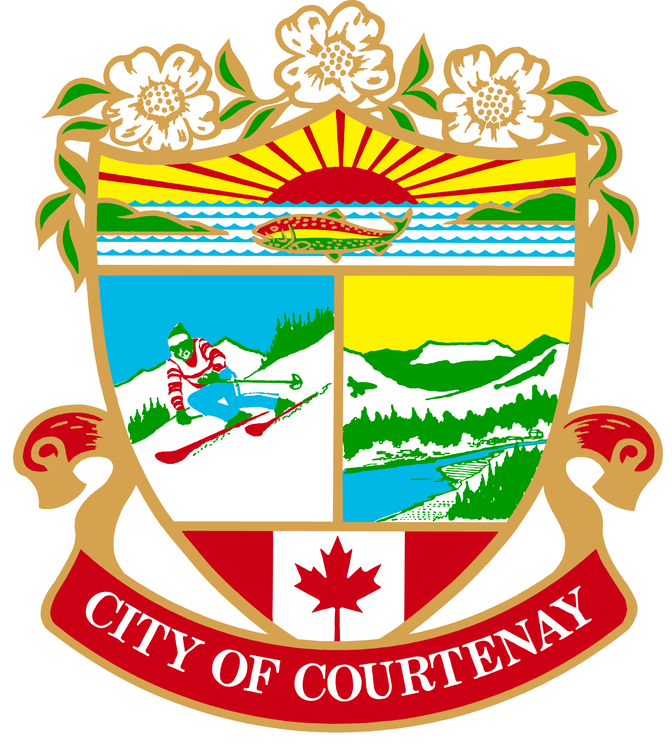
CITY OF COURTENAY
CAREER OPPORTUNITY

MANAGER OF DEVELOPMENT PLANNING
The City
The City of Courtenay is situated on the east coast of central Vancouver Island, within the traditional lands of the K'ómoks First Nation. Accessible by land, sea or air, Courtenay is a culturally diverse community that offers supernatural beauty at its doorstep. The City (approximate population 28,000) is the urban and cultural hub of the larger community, the Comox Valley (approximate population 72,000).
The City is governed by a Mayor and six Councillors. The City Manager (CAO) is responsible to Council for managing all City operations. Seven departments report to the City Manager including Corporate Services, Development Services, Engineering Services, Financial Services, Public Works Services, Recreation, Culture & Community Services and the Fire Department.
The Development Services Department is responsible for overseeing land and development processes within the City of Courtenay. The department is comprised of the following four divisions:
- The Development Planning Division is responsible for the implementation of the Official Community Plan, local area plans, zoning and other related bylaws and studies; the processing of development applications, boundary extensions, sign permits, tree cutting permits and agricultural land reserve applications; and development of the zoning bylaw.

- The Building Services Division is responsible for the implementation and enforcement of provincial building and plumbing codes and municipal bylaws relating to building construction. This division is also responsible for business licensing and administrative support for the Development Services Department.

- The Subdivision and Development Servicing Division is responsible for administration of provincial legislation and municipal bylaws related to subdivision, including the Approving Officer function, and for the administration of municipal bylaws related to servicing new development.

- The Community and Sustainability Planning Division is responsible for the development and administration of plans and policies that guide the future growth and development of the community. These include the Official Community Plan, local area plans and the co-ordination of the planning, development, implementation and monitoring of the climate action strategy, sustainability projects and initiatives both at a corporate and community level.
Our organization's culture is demonstrated by our Corporate Mission and Core Values.
The Opportunity
The Manager of Development Planning is responsible for the review of various development application processes (OCP, zoning, permits, etc); the preparation of planning studies, reports, bylaws, etc. The Manager of Development Planning also prepares and monitors budgets and manages a team of professional Planning staff.

The Successful Candidate Will Have:

- Degree in Urban Planning or related discipline.
- Membership, or eligibility for membership, in the Canadian Institute of Planners/ Planning Institute of BC
- Valid BC Class 5 Drivers License
- Considerable (7-9 years) experience in the community planning field with management experience and a focus on development approvals.
- Some experience working within a local government.
- Thorough knowledge of the philosophies, principles, and practices of municipal planning, sustainability and design.
- Strong interpersonal, communication, presentation, negotiation, research, problem solving, analytical, and management skills
- Good office computer skills
- Ability to be creative and use sound judgment in making planning decisions
- Ability to prioritize and meet deadlines
- Ability to plan, assign and direct the work of personnel and lead, coach, and motivate staff in a team environment
- Ability to deal effectively with representatives of government, business and development, the general public, City staff and Council members

COMPLEMENTARY ASSETS:
- Experience in local government planning

As we are nearing the selection of our new Director of Development Services, this is an exciting time to join us as we grow a great and dynamic team. For more information on the Development Services team, please contact Acting Director of Development Services Rob Roycroft at rroycroft@courtenay.ca or hr@courtenay.ca.

If you have the qualifications along with the passion to help Courtenay be the most livable City in British Columbia, then submit a resume outlining how you meet the qualifications with a covering letter clearly marked “Application – Manager of Development Planning”. Submit your application online at www.courtenay.ca/jobs no later than February 20, 2023.

We thank all applicants for their interest, but only those short listed will be contacted.

Notice Posted: January 25, 2023
Competition #23016

